NAMA : EKA SRI MULYANI (18090018)

KELAS : 5D

TUGAS : WP ll

PRAKTIKUM 1

1. **Source Code**

perkenalan.php -> application/controllers

1. **URL**

<http://localhost/pustaka_eka/index.php/perkenalan>

1. **Capture Hasil**

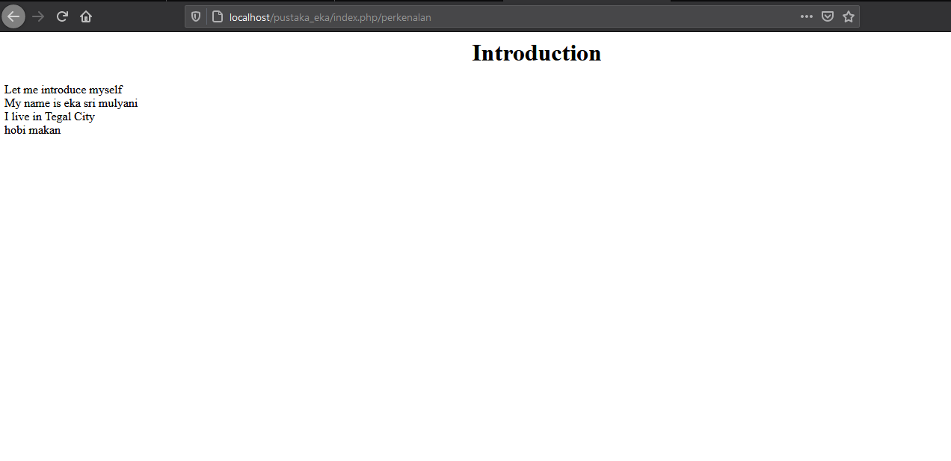

PRAKTIKUM 2

1. **Source Code**

Latihan1.php -> application/controllers

Latihan2.php -> application/controllers

view-latihan2.php -> application/views

Model1.php -> application/models

1. **URL**

[**http://localhost/pustaka_eka/index.php/Latihan1**](http://localhost/pustaka_eka/index.php/Latihan1)

[**http://localhost/pustaka_eka/index.php/Latihan1/penjumlahan/5/10**](http://localhost/pustaka_eka/index.php/Latihan1/penjumlahan/5/10)

[**http://localhost/pustaka_eka/index.php/Latihan2/penjumlahan/5/10**](http://localhost/pustaka_eka/index.php/Latihan2/penjumlahan/5/10)

1. **Capture Hasil**

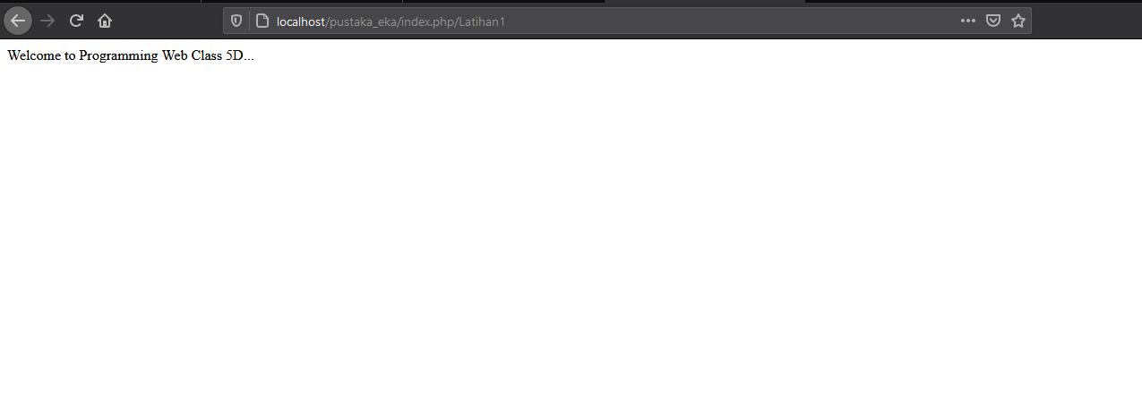

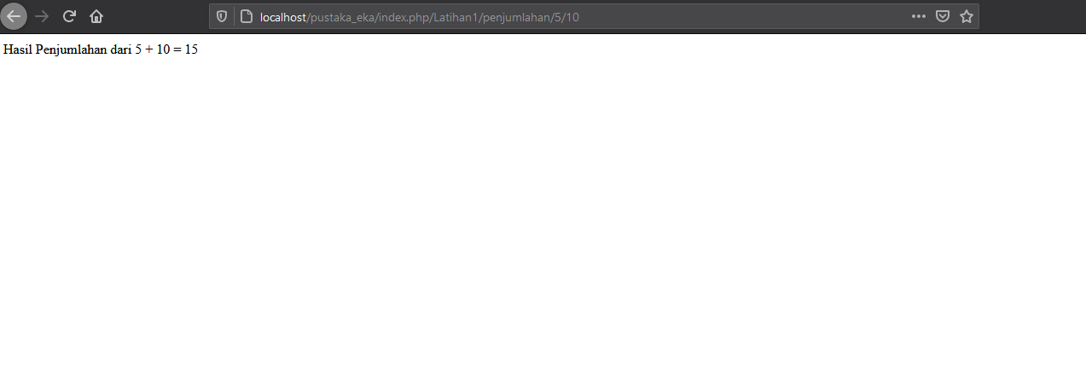

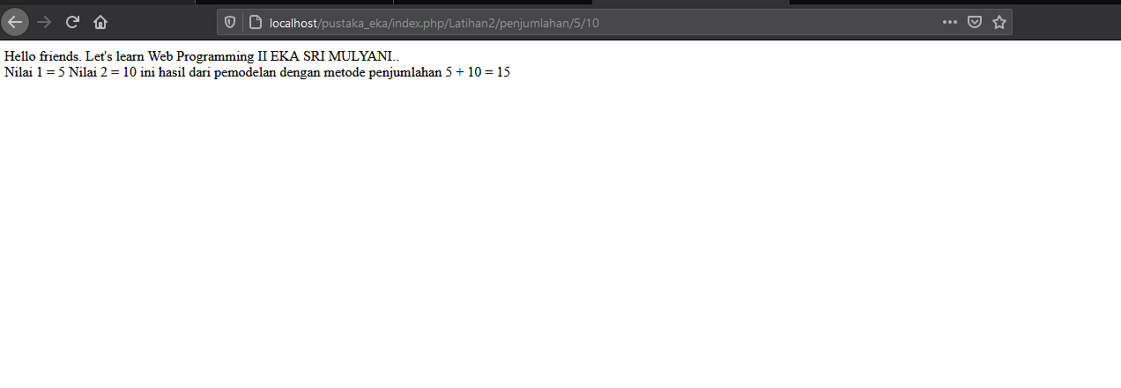

**PRAKTIKUM 3**

1. **Source Code**

view-form-matakuliah.php -> application/views

Matakuliah.php -> application/controllers

view-data-matakuliah.php -> application/views

1. **URL**

<http://localhost/pustaka_eka/index.php/matakuliah>

1. **Capture Hasil**

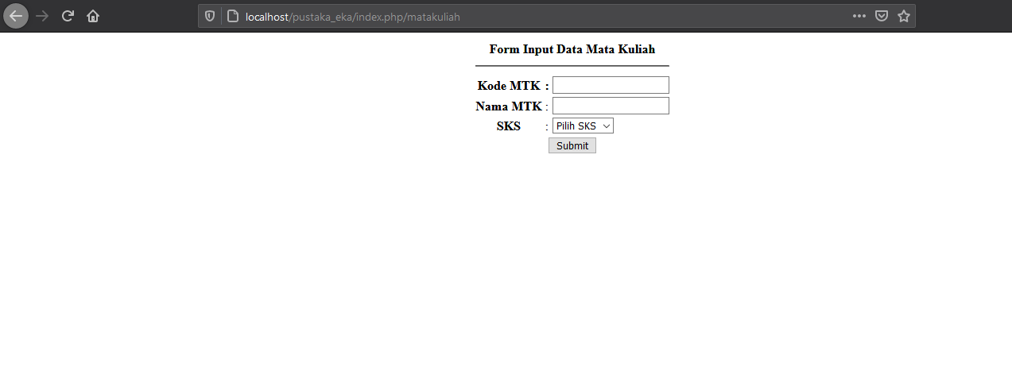

**PRAKTIKUM 4**

1. **Source Code**

Web.php -> application/controllers

v_header.php -> application/views

v_footer.php -> application/views

v_index .php -> application/views

v_about.php -> application/views

stylebuku.css -> assets/css

1. **URL**

<http://localhost/pustaka_eka/Web>

http://localhost/pustaka_eka/Web/about

1. **Capture Hasil**

**Web**

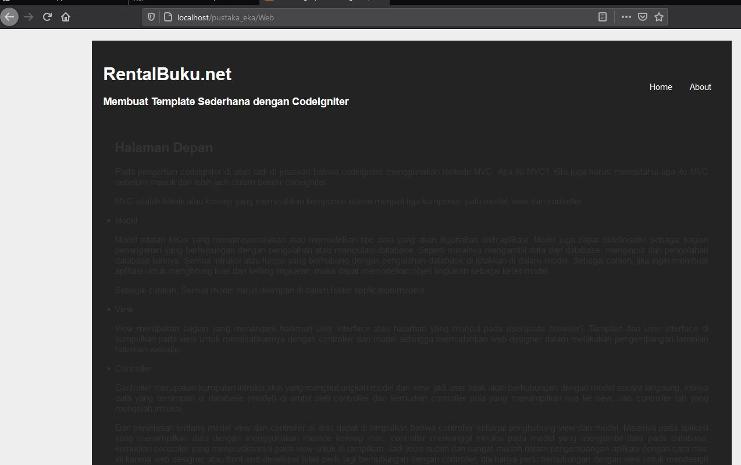

**About**

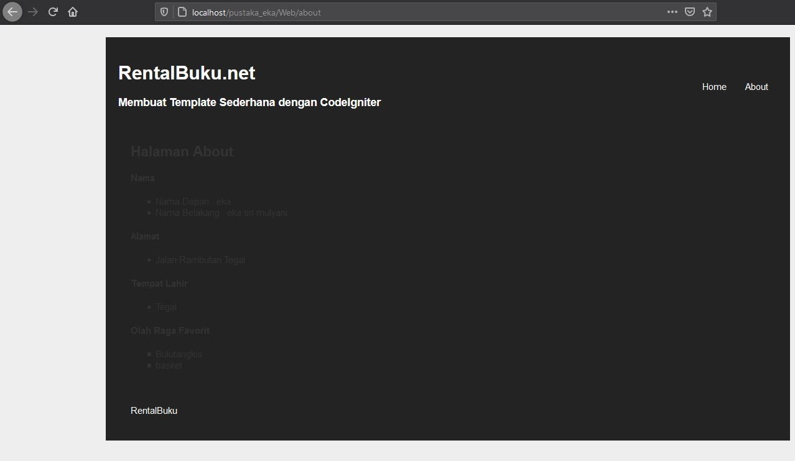

**PRAKTIKUM 5**

1. **Source Code**

MatakuliahValidation.php -> application/controllers

1. **URL**

[**http://localhost/pustaka_eka/matakuliah**](http://localhost/pustaka_eka/matakuliah)

[**http://localhost/pustaka_eka/matakuliah/cetak**](http://localhost/pustaka_eka/matakuliah/cetak)

1. **Capture Hasil**

**Matakuliah**

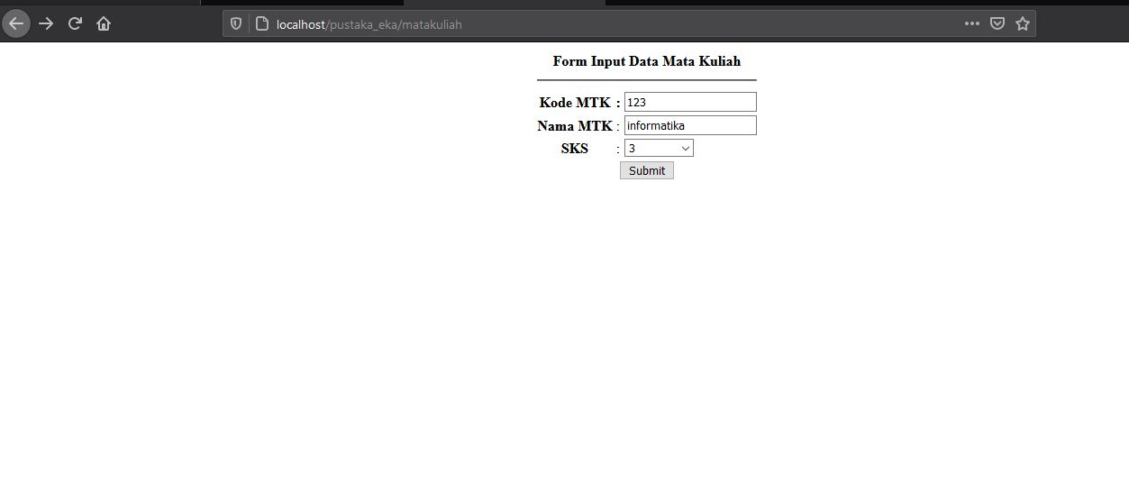

**Cetak**

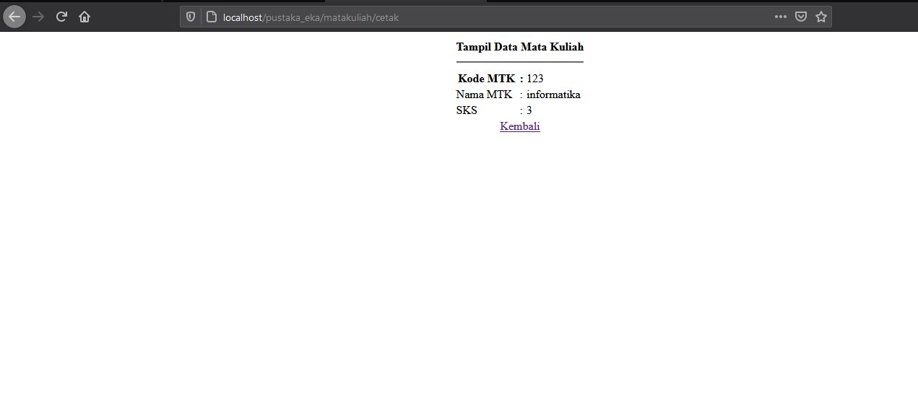

**PRAKTIKUM 6**

1. **Source Code**

ModelBuku.php -> application/models

ModelUser.php -> application/models

1. **URL**

tidak ada

1. **Capture Hasil**

**Database**

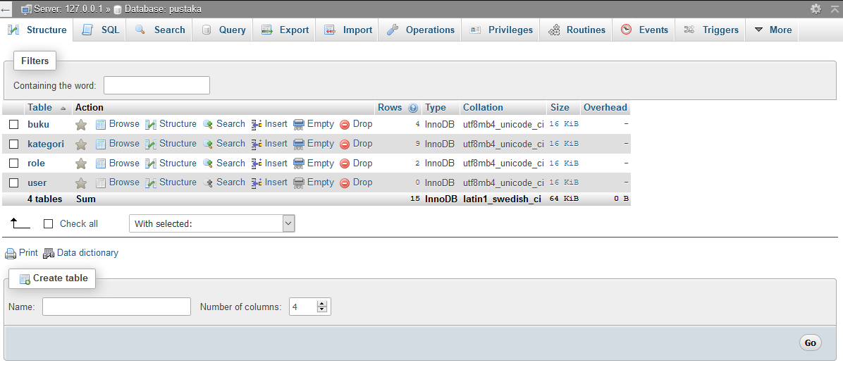

**PRAKTIKUM 7**

1. **Source Code**

Bootstrap.php -> application/controllers

v_bootstrap.php -> application/models

1. **URL**

<http://localhost/pustaka_eka/Bootstrap>

1. **Capture Hasil**

**Bootstrap**

